Reward value influences simultaneous competition for feature-based attention: Insights from Steady-State Visual Evoked Potentials

Ivan Grahek1☨*, Antonio Schettino1,2☨, Gilles Pourtois1, Ernst H.W. Koster1,

& Søren K. Andersen3

1. *Department of Experimental Clinical and Health Psychology, Ghent University, Henri Dunantlaan 2, B-9000, Ghent, Belgium*
2. *Institute for Globally Distributed Open Research and Education (IGDORE)*
3. *School of Psychology, University of Aberdeen, William Guild Building, Aberdeen, AB24 3FX, United Kingdom*

# Abstract

Keywords: attention; attentional control; EEG; feature-based attention; reward; motivation; steady-state visual evoked potentials; frequency tagging

# Introduction

Selective attention is crucial for adaptive behavior as it facilitates processing of relevant and suppression of irrelevant stimuli in our environment (Chun, Golomb, & Turk-Browne, 2011; Desimone & Duncan, 1995). This process depends on the physical salience stimuli (e.g., a loud noise) and on our current goals (e.g., searching for our keys; Corbetta & Shulman, 2002; Posner, 1980; Theeuwes, 2010). Recent research has pointed out that motivation has an important influence on selective attention as well. Goal-driven attentional control is enhanced when individuals are motivated with extrinsic rewards (Botvinick & Braver, 2015; Pessoa, 2015). Attention can also be guided by previous reward history: stimuli which used to be associated with rewards can later capture attention independently from top-down attentional control (Anderson, 2016; Awh, Belopolsky, & Theeuwes, 2012; Chelazzi, Perlato, Santandrea, & Della Libera, 2013; Failing & Theeuwes, 2017).

Goal-directed attention (as well as other cognitive control processes) is enhanced when individuals anticipate that they can earn rewards for good task-performance (for a review see: Krebs & Woldorff, 2017). A number of fMRI and EEG studies have demonstrated that these reward-based enhancements in preparation for the upcoming stimulus are driven by enhanced activity in frontoparietal regions involved in attentional control (Krebs, Boehler, Roberts, Song, & Woldorff, 2012; Pessoa & Engelmann, 2010; Schevernels, Krebs, Santens, Woldorff, & Boehler, 2014), and by enhanced task-set representations in these regions (Etzel, Cole, Zacks, Kay, & Braver, 2016; Wisniewski, Reverberi, Momennejad, Kahnt, & Haynes, 2015). Although these studies suggest that reward can influence attentional control via modulations in the frontoparietal network, it remains largely unclear how reward biases competition for selection between relevant and irrelevant stimuli in the visual cortex (Serences, 2008).

Behavioral studies have explored how goals and reward history compete for the control of attention (Anderson, 2016; Chelazzi et al., 2013; Failing & Theeuwes, 2017). More specifically, neutral stimuli previously associated with reward appear to capture attention automatically subsequently, and strongly interfere with concurent goal-related attention processes, including those involved in visual search (Anderson, Laurent, & Yantis, 2011; Della Libera & Chelazzi, 2009; Failing & Theeuwes, 2014). At the neural level, value based attention capture has sometimes been related to early effects following stimulus onset in the visual cortex (i.e., increase in the P1 component; Donohue et al., 2016; Hickey, Chelazzi, & Theeuwes, 2010; Luque et al., 2017; MacLean & Giesbrecht, 2015). However, other studies have failed to find evidence for such early modulations in the visual cortex, and found changes at later stages of stimulus processing (increased N2pc component and improved decoding in later processing stages; Qi, Zeng, Ding, & Li, 2013; Tankelevitch, Spaak, Rushworth, & Stokes, 2019). Importantly, in these earlier studies, the focus was on attentional capture by reward when it was used as distractor, and could be either high or low value. However, it remains unclear how competition for attentional selection is resolved when high and low value reward stimuli directly compete with each other, and whether sensory processing in the visual cortex reflects this competition.

Theoretical frameworks propose that the allocation of attention is facilitated towards stimuli which are (or used to be) predictive of rewards, while the processing of other stimuli is suppressed (Anderson, 2016; Awh et al., 2012; Chelazzi et al., 2013; Failing & Theeuwes, 2017). Further, Roelfsema and colleagues (2010) proposed that this effect relies on the plasticity of the visual cortex induced by the joined effect of top-down attentional control and dopamine. To date, only one fMRI study (Hickey & Peelen, 2015) has provided evidence for the simultaneous enhancement in representation of reward-related stimuli and suppression of stimuli devoid of a specific motivational value. More specifically, using a multivoxel pattern analysis and decoding technique, these authors found a gain in object-selective visual cortex for stimuli paired with rewards, while those not associated with this incentive were suppressed. Although these imaging results are undoubtedly important, they do not inform about the neurophysiological time-course of this modulatory effect created by reward on attentional selection in the visual cortex. Moreover because these authors focused on category-specific effects, the question remains whether a similar effect can be observed for lower level visual features such as color. To fill this gap, here we harnessed the high temporal resolution of EEG and the steady-state visual evoked potentials (SSVEPs) with the aim to unravel the mechanism through which reward biases competition for attention selection in the visual cortex.

To this end, participants performed a coherent motion detection task based on color information. On each trial, a blue and red random dot kinematograms (RDK) were presented concurrently at two different frequencies, and participants were cued on a trial by trial basis to attend to one of them. Thus these two RDKs served as target (attended) and distractor (unattended), respectively. Critically, after a baseline period used as control condition, these two colors were systematically associated with a low or high reward value (training phase), before that was no longer the case (test phase). Hence, we used a factorial design in which we could assess how the competition between high and low reward value is resolved by attention in the visual cortex. SSVEPs offer the unique advantage to infer how competition between high or low reward value stimuli takes place in the visual cortex as a function of attention because the specific oscillatory response of each RDK can be extracted (frequency tagging), and the two resulting signals can be compared to each other (Norcia, Appelbaum, Ales, Cottereau, & Rossion, 2015). Attended stimuli are associated with a larger SSVEP response than unattended ones (Muller et al., 2006). Hence, SSVEPs provide a continuous measure of feature-based attention when multiple stimuli are presented simultaneously and they compete with each other for selection (Andersen & Müller, 2010).

In light of the literature reviewed above, we formulated several hypotheses. First, we predicted that the processing of the target color will be enhanced (larger SSVEP amplitude) compared to the distractor color throughout all phases of the experiment. Further, we predicted that the SSVEP amplitudes will be modulated by value in the training phase. Specifically, we hypothesized that the processing of the high value stimulus will be facilitated (larger SSVEP amplitude) both when it acts as a target, and when it acts as a distractor. We also predicted that the processing of the low value stimulus will be suppressed (lower SSVEP amplitude) compared to baseline. This effect will also be observable in the behavior thorough as task-performance improvements in the training phase, which will be more pronounced when the high value color is attended. Finally, we hypothesized that these effects of value, on both the SSVEP amplitudes and behavior, will have a long lasting effect and thus be observable in the test phase when rewards will no longer be available.

# Methods

## Participants

We tested 48 participants with normal or corrected-to-normal vision and no history of psychiatric or neurological disorders. Four participants were excluded due to technical problems during EEG recording. Thus, the final data set consisted of 44 participants (30 females, 14 males; median age = 22). Participants received a fixed payoff of 20 €, plus up to 6 € depending on task performance (on average 25.5 €). The study was approved by the ethics committee of Ghent University.

## Stimuli and task

We used the coherent motion detection task (Andersen & Müller, 2010; *Figure 1A*), in which participants were presented with two overlapping circular RDKs of isoluminant colors (red and blue) on a grey background. Viewing distance was fixed with a chinrest at 55 cm from the 21-inch CRT screen (resolution of 1024 x 768 pixels, 120 Hz refresh rate). At the beginning of each trial, participants were instructed which of the two RDKs to attend by a verbal audio cue: “red” (241 ms) or “blue” (266 ms). The two RDKs had a diameter corresponding to 20.61 degrees of visual angle and consisted of 125 randomly and independently moving dots each (0.52 degrees of visual angle per dot). The two RDKs flickered at a different frequencies (10 or 12 Hz). One-third of trials contained one, two, or three coherent motion intervals, occurring with equal probability in the attended (targets) or unattended (distractors) color RDK. During these intervals, dots in one of the RDKs moved with 75% coherence in one of four cardinal directions (up, down, left, or right) for 300 ms. Participants had to detect the occurrence of coherent motion in the cued RDK as fast as possible by pressing the space key on a standard AZERTY USB keyboard while ignoring such coherent motion in the uncued RDK. Responses occurring between 200 ms and 1500 ms after coherent motion onset of the cued or uncued dots were counted as hits or false alarms, respectively. Correct responses were followed by a tone (200 ms sine wave of either 800 or 1,200 Hz, counterbalanced across participants). Late or incorrect responses were followed by an error sound (200 ms square wave tone of 400 Hz).

The experiment started with 4 practice blocks of 60 trials. After each block, participants received feedback on their performance. After finishing the practice phase, participants completed 12 blocks of 50 trials divided into 3 phases (*baseline*, *training*, and *test*; *Figure 1B*). Each phase contained 100 trials on which participants were instructed to attend to the red color and 100 trials in which they were instructed to attend to the blue color. Out of those 100 trials, 40 trials contained no dot motion, and 60 trials contained one, two, or three dot motions (120 motions in total). Participants did the coherent motion detection task, as described above, throughout all three phases (baseline, training, and test). In the training phase, participants could earn additional monetary rewards (up to 6 €) based on their actual performance. They were instructed that one of the colors would be paired with high probability (80%) and the other color with low probability (20%) of earning 10 extra cents for each correct detection. The mapping between color and value was counterbalanced across participants. The receipt of the reward was signaled by a new tone that replaced the usual correct tone. If the correct tone was a sine wave of 800 Hz, the reward tone was a sine wave of 1,200 Hz and vice versa. At the end of each of the 4 blocks of the training phase, participants got feedback on both their performance and the amount of extra money earned within the block. The third phase (test) was identical to baseline (i.e., no monetary rewards assigned). The whole task lasted for approximately 50 minutes, including a short break in between blocks. After completing the task, participants filled in two questionnaires aimed at assessing their reward sensitivity (BIS-BAS; Franken et al., 2005) and depression levels (BDI-II; Van der Does, 2002). The questionnaire data is not reported here. This experiment was realized using Cogent 2000 developed by the Cogent 2000 team at the FIL and the ICN and Cogent Graphics developed by John Romaya at the LON at the Wellcome Department of Imaging Neuroscience.

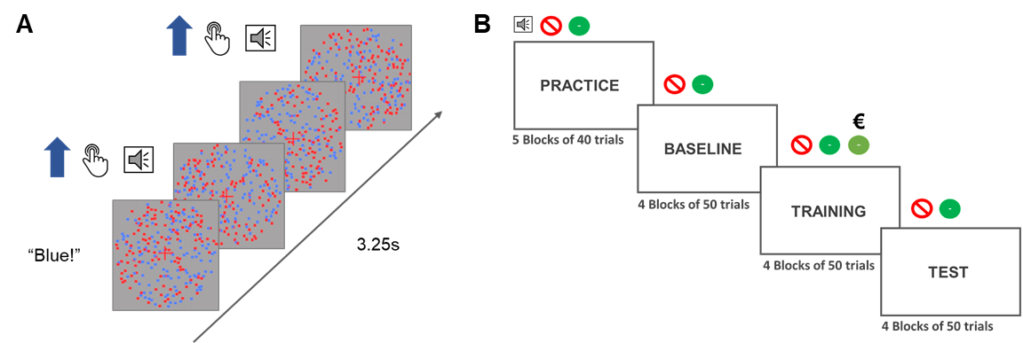

**Figure 1. Depiction of a signle trial and the phases of the experiment. A)** Each trial started with an audio cue (”Blue” or ”Red”) which instructed participants which color to attend to in that trial. The trial lasted for 3.25 seconds during which dots of either of the colors could move from 0 to 3 times in total. If the participants were instructed to attend to the blue dots and the blue dots moved coherently, they had to press the response button. In that case they would hear the auditory feedback signaling the correct detection of the motions. **B)** The experiment started with a practice and a baseline block in which the participants heard an audio cue at the beginning of the trial and two types of feedback sounds (incorrect or correct). In the training block a third sound was introduced to signal that the participants were both correct and received a reward for that response. They would still at times hear the the old correct feedback which would signal that they were correct, but not rewarded. The test phase was the same as the baseline phase.

## EEG recording and data pre-processing

Electroencephalographic activity (EEG) was recorded with an ActiveTwo amplifier (BioSemi, Inc., The Netherlands) at a sampling rate of 512 Hz. Sixty-four Ag/AgCl electrodes were fitted into an elastic cap, following the international 10/10 system (Chatrian, Lettich, & Nelson, 1985). The common mode sense (CMS) active electrode and the driven right leg (DRL) passive electrode were used as reference and ground electrodes, respectively. Additional external electrodes were applied to the left and right mastoids, as well as on the outer canthi of each eye and in the inferior and superior areas of the left orbit (to record horizontal and vertical electrooculogram, EOG).

Data pre-processing was performed offline with custom MATLAB scripts and functions included in EEGLAB v14.1.1b (Delorme & Makeig, 2004). After subtracting the mean value of the signal (DC offset), the continuous EEG data were epoched between 0 and 3,250 ms, corresponding to the beginning and end of the trial, respectively. After referencing to *Cz*, FASTER v1.2.3b (Nolan, Whelan, & Reilly, 2010) was used for artifact identification and rejection using the following settings: (i) over the whole normalized EEG signal, channels with variance, mean correlation, and Hurst exponent exceeding *z* = ±3 were interpolated via a spherical spline procedure (Perrin, Pernier, Bertrand, & Echallier, 1989); (ii) the mean across channels was computed for each epoch and, if amplitude range, variance, and channel deviation exceeded *z* = ±3, the whole epoch was removed; (iii) within each epoch, channels with variance, median gradient, amplitude range, and channel deviation exceeding *z* = ±3 were interpolated; (iv) grand-averages with amplitude range, variance, channel deviation, and maximum EOG value exceeding *z* = ±3 were removed; (v) epochs containing more than 12 interpolated channels were discarded. All remaining epochs were scanned with SCADS (Junghöfer, Elbert, Tucker, & Rockstroh, 2000) and rejected when flagged as containing residual artifacts. For details, see our commented code at https://osf.io/5hryf/. After pre-processing, the average number of interpolated channels was 3.61 (*SD* = 1.23, range 1 – 6) and the mean percentage of rejected epochs was 8.77% (*SD* = 6.71, range 0 – 27.78). After re-referencing to averaged mastoids, trials in each condition were averaged separately for each participant, resulting in the following grand-averages: (i) baseline, red attended; (ii) baseline, blue attended; (iii) training, red attended; (iv) training, blue attended; (v) test, red attended; (vi) test, blue attended.

Electrodes with maximum SSVEP amplitudes were identified by calculating isocontour voltage maps based on grand-averaged data collapsed across all conditions. After removing linear trends, Fast Fourier Transforms on the EEG signal in a time window from 500 ms (to exclude the typically strong phasic visual evoked response to picture onset) to 3,250 ms after stimulus onset was applied, and amplitudes were obtained by extracting the absolute values of the resulting complex Fourier coefficients. We extracted SSVEP amplitude at 10 and 12 Hz from each individual electrode cluster, separately for each condition (averaged across trials). The amplitudes were normalized (rescaled) for each participant and frequency separately by dividing amplitudes by the average amplitude of the two conditions in the baseline. To account for inter-individual variations in topographical SSVEP amplitude distributions, we identified and averaged activity from the four electrodes displaying, for each participant, the largest frequency-specific amplitude.

For the behavioral data, mean reaction times of correct detections (hits) and sensitivity d′ were analyzed. Sensitivity index d′ (Macmillan & Creelman, 2004) was calculated with adjustments for extreme values (Hautus, 1995) using the *psycho* R package (for the method see: Pallier, 2002).

## Statistical analyses

Behavioral and EEG data were analyzed using Bayesian multilevel regressions. We fitted and compared multiple models of varying complexity to predict sensitivity (d`), reaction times for correct responses, and SSVEP amplitudes. Each of the fitted models included both constant and varying effects (also known as fixed and random). Participant-specific characteristics are known to affect both behavioral performance (e.g., response speed) and EEG signal (e.g., skull thickness, skin conductance, hair); therefore, we decided to model this variability by adding varying intercepts in our models. Additionally, the studied effects (i.e., selective attention and value) are known to vary in magnitude over participants, so we opted for including varying slopes in our models. It should be noted that, because of the simultaneous estimation of group-level and participant-level parameters, multilevel models display a property called *shrinkage[1]*.

Models were fitted in R using the *brms* package (Bürkner, 2016) which employs the probabilistic programming language *Stan* (Carpenter et al., 2016)to implement Markov Chain Monte Carlo (MCMC) algorithms in order to estimate posterior distributions of the parameters of interest (details about the fitted models can be found in the data analysis scripts). Each of the models were fitted using weakly informative prior distributions (described below) and Gaussian likelihood. Four MCMC simulations (“chains”) with 6,000 iterations (3,000 warmup) and no thinning were run to estimate parameters in each of the fitted models. Further analyses were done following the recommendations for Bayesian multilevel modeling using *brms* (Bürkner, 2016, 2017; Nalborczyk & Bürkner, 2019). We confirmed that all models converged by examining trace plots, autocorrelation, and variance between chains (Gelman-Rubin statistic; Gelman & Rubin, 1992). We compared models based on their fit to the actual data using the Bayesian *R*2 (Gelman, Goodrich, Gabry, & Ali, 2017), and their out-of-sample predictive performance using the Widely Applicable Information Criterion (WAIC; Watanabe, 2010). The best model was selected and the posterior distributions of conditions of interest were examined. Differences between conditions were assessed by computing the mean and the 95% highest density interval (HDI) of the difference between posterior distributions of the respective conditions (Kruschke, 2014). Additionally, we calculated the evidence ratios (ERs) for our hypotheses as the ratios between the percentage of posterior samples on each side of the zero of a difference distribution between two conditions. ERs can be interpreted as the probability of a hypothesis (e.g. “Condition A is larger than condition B”) against its alternative (“Condition B is larger than condition A”).

### Behavior

We fitted three models to predict sensitivity (d`) and reaction times (in milliseconds) separately (*Figure 2* for the raw data and *Supplementary Table 1* for the descriptive statistics). First, we fitted the *Null model* with a constant and varying intercepts across participants. This model was fitted in order to explore the possibility that the data would be best explained by simple random variation between participants. To investigate the effect of reward phase (baseline, training, test), we fitted the *Reward phase* model which included only reward phase as the constant predictor, as well as varying intercepts and slopes across participants for this effect. To investigate the possible interaction between reward phase and value, we fitted the *Reward phase * Value* model including the intercepts and slopes of these two effects and their interaction as both constant and varying effects. All models had a Gaussian distribution as the prior for the intercept (for sensitivity: centered at 1.8 with a standard deviation of 1; for reaction times: centered at 500 with a variance of 200). The models with slopes also included a Gaussian distribution as the prior for the slopes (for sensitivity: centered at 0 with a standard deviation of 2; for reaction times: centered at 0 with a standard deviation of 200). These weakly informative priors were chosen based on the previous study which used the same task (Andersen & Müller, 2010). Note that there are two additional models that, although possible to fit, are not plausible in the context of our experiment. Specifically, the model with only the effect of value overlooks the fact that this effect would necessarily be most pronounced in the training phase, thus interacting with the effect of reward phase. The same logic applies to the model with additive effects of reward phase and probability (i.e., these effects could not act independently in our experimental design).

### SSVEP amplitudes

We fitted seven models to predict the trial-averaged SSVEP amplitudes (in a.u. due to the normalization) across conditions (*Figure 2C, Figure 2D,* and *Supplementary* *Table 2*). The *Null model* included one constant and multiple varying intercepts across participants. The *Attention model* included the constant effect of attention; the *Reward Phase model* included the constant effect of reward phase; the *Reward Phase + Attention* model included the additive effects of reward phase and attention; and the *Reward Phase * Attention* model also included the interaction between reward phase and attention. The *Value * Reward phase + Attention* model consisted of the constant effects of value and phase, their interaction, and the independent effect of attention. The last model was the *Value * Reward phase * Attention* model which included all constant effects and their interaction. All models, except for the *Null* *model*, included varying intercepts and slopes across participants for all of the constant effects. All models included a Gaussian distribution as the prior for the intercept (centered at 1 with a standard deviation of 3). In addition, the models with slopes included a Gaussian distribution as the prior for the slopes (centered at 0 with a standard deviation of 3). These weakly informative priors were chosen based on the previous study with the same task (Andersen & Müller, 2010). As was the case for the behavioral data, several models were not fitted because they were not plausible in the context of our experiment (e.g., the models that include both reward phase and probability, but not their interaction).

# Results

## Behavioral results

### Sensitivity d′

Of all the tested models, the *Reward phase * Value* model best predicted sensitivity (*Table 1*). The posterior distributions of the interaction model (*Figure 2A* and *Table 2*) revealed that sensitivity improved in the training phase compared to the baseline for both the low value (*M =* 0.18; 95% HDI [0.06, 0.31]; ER = 499.00) and the high value color (*M =* 0.04; 95% HDI [-0.08, 0.17]; ER = 2.92). This improvement was far more pronounced for low compared to high value (*M =* 0.14; 95% HDI [-0.03, 0.31]; ER = 17.18). Conversely, there was no evidence for a difference between training and test phases in the low (*M =* 0.00; 95% HDI [-0.13, 0.13]; ER = 1.08), and only a very small reduction in sensitivity in the high value condition (*M =* -0.03; 95% HDI [-0.16, 0.11]; ER = 2.42). These results suggest a higher sensitivity for coherent motion detection in the training phase compared to baseline, and far more so for the low relative to the high value color. There was also very little evidence of a change in sensitivity from the training to the test phase.

|  |  |  |  |  |
| --- | --- | --- | --- | --- |
| Table 1  *Mean and standard errors (in parenthesis) of WAIC and Bayesian R2 for each model predicting sensitivity and reaction times.* | | | | |
| Model | | *WAIC (SE)* | | *Bayesian R2 (SE)* |
| *Sensitivity* | | | | |
| Null | | 446.33 (23.43) |  | 0.22 (0.05) |
| Reward phase | | 451.47 (22.74) |  | 0.24 (0.05) |
| Reward phase * Value | | 200.57 (21.27) |  | 0.76 (0.22) |
| *Reaction times* |
| Null | | 2,541.30 (26.80) |  | 0.58 (0.03) |
| Reward phase | | 2,511.86 (27.49) |  | 0.64 (0.03) |
| Reward phase * Value | | 2,324.94 (23.46) |  | 0.87 (0.02) |

|  |  |  |  |
| --- | --- | --- | --- |
| Table 2  *Means and 95% HDIs of the posterior distributions of reaction times and sensitivity in each condition.* | | | |
| Reward phase | Value | Sensitivity (d`) | Reaction times (milliseconds) |
| Baseline | High | 1.74 [1.55, 1.90] | 551.15 [538.76, 563.40] |
| Baseline | Low | 1.50 [1.31, 1.69] | 556.82 [543.65, 570.10] |
| Training | High | 1.78 [1.59, 1.96] | 528.87 [516.89, 541.25] |
| Training | Low | 1.68 [1.49, 1.87] | 542.01 [530.03, 554.53] |
| Test | High | 1.75 [1.58, 1.93] | 533.06 [518.87, 547.36] |
| Test | Low | 1.68 [1.49, 1.87] | 540.89 [526.07, 555.71] |

**Figure 2. Raw and modelled data.** Violin plots displaying raw data for each participant (grey dots), separately for each condition. Results from the winning models are presented in blue (dark blue – 50% HDIs and light blue – 95% HDIs). **A)** Sensitivity (*d`*) **B)** Reaction times (ms) **C)** SSVEP amplitudes (arbitrary units) in response to the color related to high value on trials in which it acts as target or distractor. **D)** SSVEP amplitudes for the color linked to low value on trials when it acts as target or distractor.

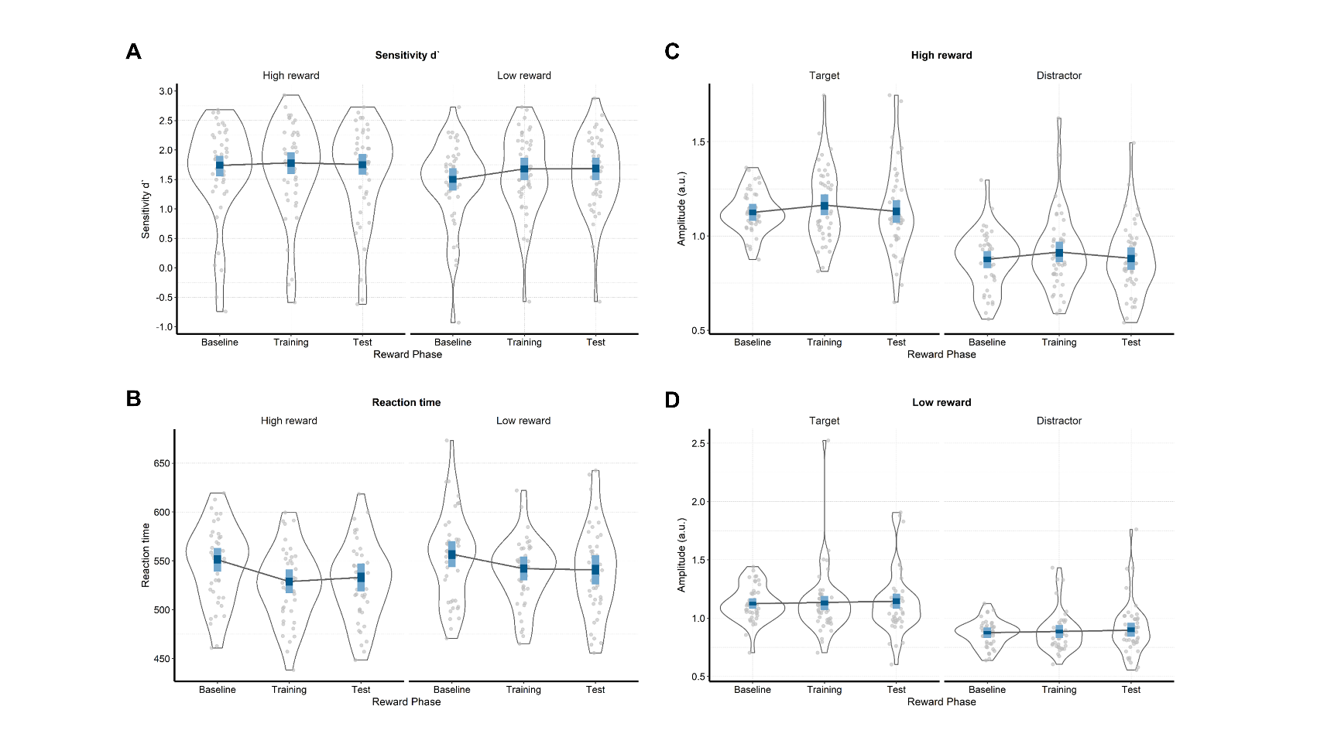

### Reaction times

The *Reward phase * Value* model also best predicted the reaction times (*Figure 2B* and *Table 1*). In the training, compared to the baseline phase, participants were reliably faster in detecting the motions of both the high (*M =* -22.30; 95% HDI [-30.30, -14.40]; ER = *Inf.*, i.e. the whole posterior distribution was below zero) and the low value colors (*M =* -14.80; 95% HDI [-22.80, -6.52]; ER = *Inf.*). Moreover, this difference between baseline and training was larger for detecting motions of the high relative to low value color (*M =* -7.46; 95% HDI [-16.50, 1.99]; ER = 16.24). We found less evidence for changes in reaction times between the training and the test phase. There was a very small increase in the reaction times in the test compared to training phase for the high value color (*M =* 4.19; 95% HDI [-3.94, 11.80]; ER = 5.62), and no difference for the low value (*M =* -1.12; 95% HDI [-9.11, 6.68]; ER = 1.59). These results indicate that participants were faster in detecting coherent motions in the condition in which they could earn rewards (training), and more so for high than low value color. Also, there was a very small increase in the reaction times for the high reward condition and no difference in the low reward condition when the rewards were no longer available (test). Supplementary analyses carried out to assess possible training effects indicated some evidence for the presence of training effects in sensitivity and scant evidence for such effects in reaction times (*Supplementary materials*).

## SSVEP amplitudes

As shown in *Figure 3* SSVEP amplitudes averaged over conditions was mainly localized at central occipital channels (i.e., *Oz*, *POz*, *O2*, *PO3*). Also, the amplitude spectra showed the expected peaks at the frequencies of 10 and 12 Hz.

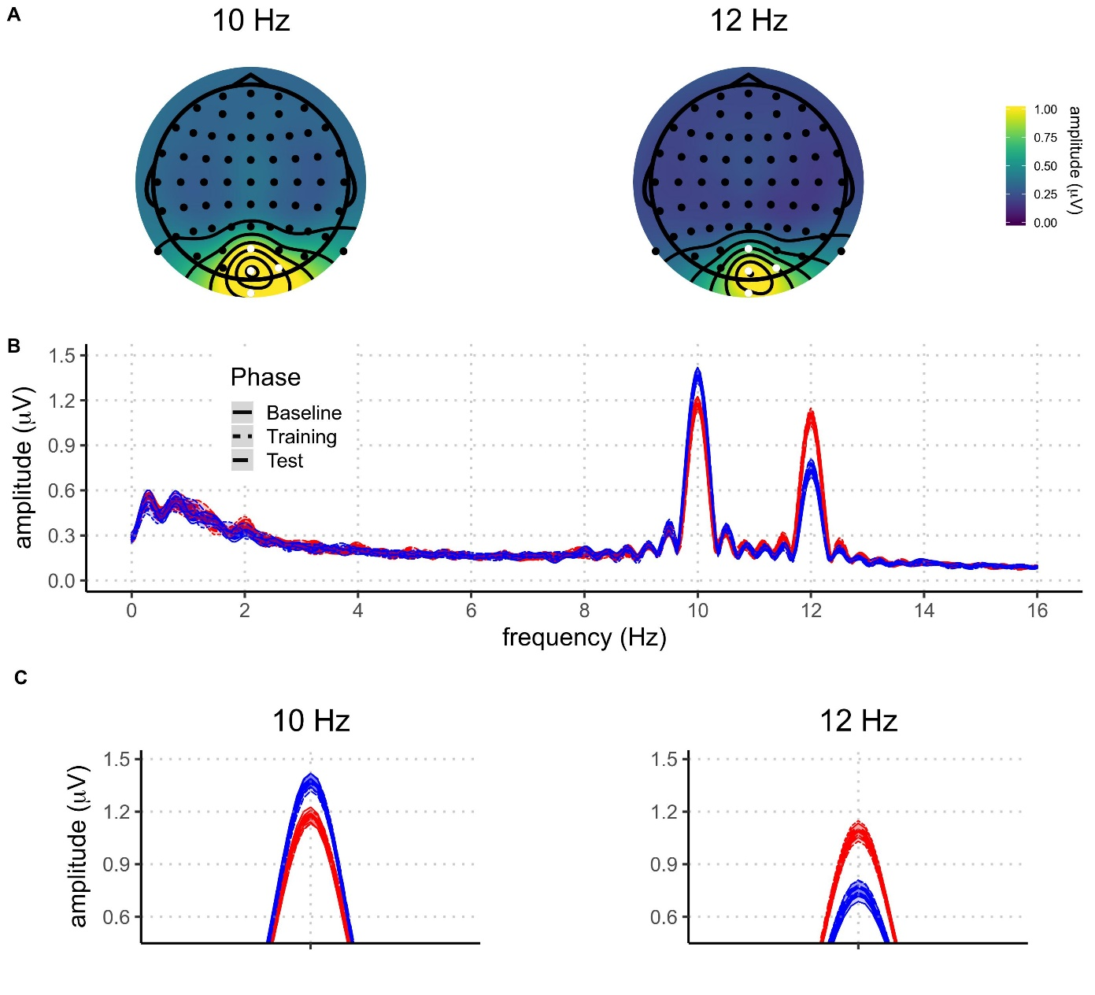

**Figure 3.** **A)** Topographies of SSVEP amplitudes, averaged across all participants and conditions, at 10 Hz and 12 Hz. Electrodes selected for the analysis are highlighted in white. **B)** Grand average amplitude spectra derived from EEG signals at each participant’s best four-electrode cluster for the different experimental conditions (blue: attended; red: unattended; solid: baseline phase; dotted: rewarded phase; dashed: non-rewarded phase). The shaded areas around the means indicate 95% confidence intervals.

The *Value * Reward phase + Attention* model best predicted SSVEP amplitudes across conditions (*Table 3*). However, the *Value * Reward phase * Attention* was only slightly worse than the winning model. Here we draw inferences from the winning model, but note that the conclusions do not substantially change when analyzing the model which includes the three-way interaction. The analysis of the posterior distributions of the winning model (*Figure 2* and *Table 3*) revealed a strong effect of voluntary selective attention: in all conditions, SSVEP amplitudes were higher when the eliciting stimulus was attended (target) compared to when it was unattended (distractor). In the winning model, this effect did not interact with the other factors in the model, i.e. the magnitude of selective attention was unaffected by reward value and reward phase. The posterior distribution of the difference between target and distractor stimuli did not include zero, thus resulting in infinite probability that the target stimuli would elicit higher SSVEP amplitudes compared to the distractor ones (*M =* 0.25; 95% HDI [0.20, 0.30]; ER = *Inf*). These results reveal a very robust effect of voluntary selective attention across all experimental conditions: the SSVEP response was systematically larger when the driving stimulus was attended.

|  |  |  |  |
| --- | --- | --- | --- |
| Table 3  *Model comparison indices for EEG results* | | | |
| Model | *WAIC (SE)* |  | *Bayesian R2 (SE)* |
| Null | 65.34 (62.67) |  | 0.08 (0.02) |
| Reward phase | 16.17 (59.31) |  | 0.14 (0.02) |
| Attention | -341.85 (70.91) |  | 0.40 (0.02) |
| Reward phase + Attention | -428.76 (67.19) |  | 0.46 (0.02) |
| Reward phase * Attention | -424.98 (67.36) |  | 0.46 (0.02) |
| Value * Reward phase + Attention | -647.37 (74.90) |  | 0.59 (0.01) |
| Reward phase * Value * Attention | -638.31 (74.97) |  | 0.59 (0.01) |
|  | | | |

|  |  |  |  |
| --- | --- | --- | --- |
| Table 4  *Means and 95% HDIs of the posterior distributions of the SSVEP amplitudes for each condition.* | | | |
| Attention | Reward phase | Value | Amplitudes (a.u.) |
| Target | Baseline | High | 1.12 [1.08, 1.17] |
| Target | Baseline | Low | 1.12 [1.08, 1.17] |
| Target | Training | High | 1.16 [1.11, 1.22] |
| Target | Training | Low | 1.13 [1.07, 1.19] |
| Target | Test | High | 1.13 [1.07, 1.19] |
| Target | Test | Low | 0.90 [0.84, 0.96] |
| Distractor | Baseline | High | 0.88 [0.83, 0.92] |
| Distractor | Baseline | Low | 0.87 [0.83, 0.92] |
| Distractor | Training | High | 0.91 [0.86, 0.97] |
| Distractor | Training | Low | 0.89 [0.83, 0.94] |
| Distractor | Test | High | 0.88 [0.82, 0.94] |
| Distractor | Test | Low | 0.90 [0.84, 0.96] |

The winning model also included the interaction between reward phase and value, but this interaction remained the same for both targets and distractors. SSVEP amplitudes were higher in the training phase than in the baseline for the high value color (*M =* 0.04; 95% HDI [-0.01, 0.09]; ER = 15.13), both when it acted as a target and as a distractor. However, there was no evidence of difference for the change in SSVEP amplitudes from baseline to training for the low value color (*M =* 0.01; 95% HDI [-0.04, 0.06]; ER = 2.02). Comparing the training to the test phase, the amplitudes of the high value color were reduced (*M = -*0.03; 95% HDI [-0.06, 0.04]; ER = 15.66), while the amplitudes of the low value color did not change (*M =* -0.01; 95% HDI [-0.05, 0.04]; ER = 2.17). To summarize, visual processing of the high value color stimulus was enhanced in the phase in which participants could earn monetary rewards and went back to baseline in the subsequent test phase without rewards. Thus change occured irrespective of whether that color was attended or not. Finally, visual processing of the low reward color remained constant across the three phases of the experiment.

# Discussion

In this study we investigated the neural mechanisms through which rewards enhance goal-directed attention. We compared the amount of attention allocated toward targets and distractors of different values. Compared to baseline, the introduction of rewards improved detection sensitivity and reaction times in the coherent motion detection task. Further, coherent motion of dots linked to higher value were detected faster, which was accompanied by an increased amount of attention allocated toward these stimuli, as measured by the amplitude of the corresponding SSVEP. This was true both when the high value color was a target and a distractor. When rewards were no longer available, the amount of attention went back to baseline levels, but participants were still faster to detect coherent motions of high value targets. These findings have several important implications for understanding the relationship between motivation and goal-directed attention.

Our behavioral findings are in line with studies showing the incentive-based improvements in attentional control (Krebs et al., 2012; Padmala & Pessoa, 2011). Our results are also compatible with a value based attention capture, which was usually demonstrated by the pervasive and lingering effect of previously learned reward associations on attention allocation, even though these associations are no longer task relevant (Anderson, 2016). More specifically, such studies typically found that stimuli previously related to high rewards involuntarily capture attention, which is demonstrated by the increased reaction times in visual search and spatial cueing tasks on trials when these stimuli act as distractors (Anderson, Laurent, & Yantis, 2011; Della Libera & Chelazzi, 2009; Failing & Theeuwes, 2014). While these studies usually used two different tasks for the training and the test phases, here we show that a similar value based attention capture effect can be found when task demands remain unchanged across all phases. Participants were faster to detect coherent motion when it was embedded in a high compared to low reward RDK. This difference was clearly present in the training phase, but also in the subsequent test phase where behavior was no longer rewarded. This observation is compatible with the assumption that reward history can exert long lasting effects on the guidance of selective attention, even if this effect is actually unrelated to the current goals (Anderson, 2016; Failing & Theeuwes, 2017).

At the neural level, we found that the SSVEP response provided a valid measure of feature-based attention as its amplitude was clearly larger for attended (target) compared to unattended (distractor) RDKs, thereby confirming previous findings (Andersen, Müller, & Hillyard, 2012; Andersen & Müller, 2010). This gain control effect was not only confined to the baseline phase (before value was introduced), but clearly visible in all three phases of the experiment, including training and test. Crucially, this robust attention effect was modulated by value. Model comparison showed that the models which took into account value accounted for the SSVEP data much better than the model which included only the effect of goal-directed attention. This result accords with and extends previous fMRI (Krebs et al., 2012; Pessoa & Engelmann, 2010) and EEG results (Schevernels et al., 2014), which showed that rewards can enhance attentional control. More generally, our findings accord with several theoretical models according to which motivation plays a crucial role in attention (Awh et al., 2012; Pessoa, 2015) and, more broadly, cognitive control (Brown & Alexander, 2017; Holroyd & McClure, 2015; Shenhav, Botvinick, & Cohen, 2013; Verguts, Vassena, & Silvetti, 2015).

Crucially, our results shed new light on the mechanism through which rewards influence goal-directed attention. While previous studies have mostly focused on the influence of rewards on attention prior to stimulus processing (preparatory phase), here we could examine genuine stimulus-related neural processing by means of SSVEPs, and changing as a function of value and attention concurrently. Confirming what we have hypothesized, our SSVEP results indicate that the introduction of rewards facilitated processing of stimuli linked to high reward value. This facilitation is likely localized in the V1-V3 areas of the visual cortex, in which the attentional modulation of the SSVEP signal in the current paradigm occurs (Andersen & Müller, 2010; Andersen, Hillyard, & Müller, 2008). It is likely that the enhanced anticipatory frontoparietal activity reported in fMRI studies of reward attention (Krebs & Woldorff, 2017) leads to the increase in the processing of reward-related targets in the visual cortex which we observe. Our finding is in line with the previous fMRI studies indicating improved processing of stimuli linked to high rewards (Hickey & Peelen, 2015; Serences, 2008). Importantly, the facilitated processing of the high value color was present both when that color was a target and a distractor. When the high value color was a distractor, the facilitated processing of the color was in collision with the goal to attend to the other color. This finding is in line with the theories proposing that reward associations can counteract top-down attentional control (Chelazzi et al., 2013; Anderson, 2016; Failing & Theeuwes, 2018). Notably, facilitated processing of the distractor in this case did not lead to worse or slower detection of the targets compared to baseline. However, participants were slower in detecting the motion of the targets on these trials compared to the trials with targets of high value.

Our paradigm allowed us to simultaneously measure the processing of stimuli linked to both high and low value. Some initial evidence for the suppression of the stimuli linked to low compared to high rewards has been found at the behavioral and neural level (Hickey & Peelen, 2015; Padmala & Pessoa, 2011). Suppression of the features linked to low or no rewards has also been proposed as one of the potential mechanisms through which incentives impact attention (Chelazzi et al., 2013; Anderson, 2016; Failing & Theeuwes, 2018). Contrary to this, in this study we have not found evidence for this proposal. Suppression was not present neither when the low value color was the target, nor when it was the distractor. The amount of attention allocated toward this feature remained unchanged throughout the experiment. There are two features of our experiment which could explain this finding. First, in our experiment both colors were related to rewards, but they differed in reward value. For example, the study which showed evidence for the suppression of the non-rewarded feature did so in the context in which suppression occurred for the representations of objects which were never rewarded (Hickey & Peelen, 2015). In our paradigm it could be adaptive for participants not to suppress the low value color because correct responses to the motions of this color would still earn them a reward on 20% of trials. Second, while the attended color changed trial-by-trial in our experiment, the experiment of Hickey and Peelen consisted out of small blocks of 16 trials in which the attended object was always the same (e.g., searching for a car in a complex picture). When searching for one object or feature across a number of future trials, it is possible that the optimal solution for the cognitive system is to suppress the processing of the other features or objects (i.e., distractors). However, if the attended feature is likely to change on each trial, as in our experiment, the suppression of the low rewarded feature could be maladaptive as it would carry a cost of reconfiguring the control signals on every trial (for a computational implementation of a reconfiguration cost see: Musslick, Shenhav, Botvinick, & Cohen, 2015). Both of these explanations could be tested within our experimental paradigm. Replacing the low rewarded feature with a no-reward feature, or introducing small blocks could lead to a better understanding of the boundary conditions of attentional suppression in the context of rewards.

In the test phase behavior displayed the similar patterns as in the training phase. Individuals were faster to detect motions of the dots in color related to high value. This finding follows the reward-history effects reported in several paradigms (Anderson, Laurent, & Yantis, 2011; Della Libera & Chelazzi, 2009; Failing & Theeuwes, 2014). However, our SSVEP results show that the amount of attention allocated toward the high value color was the same in the test phase as in the baseline. This result indicates that the longer lasting effect of reward history was not mediated by attention as measured by the SSVEPs. A possible explanation for this finding is that our measure captures the more sustained aspect of attention, while the effects of reward-history on the visual processing rely on more transient attentional capture (Donohue et al., 2016; Hickey et al., 2010; Luque et al., 2017; MacLean & Giesbrecht, 2015). However, there are at least two studies which have not found evidence for the effects of reward history on the early visual processing (Qi et al., 2013; Tankelevitch et al., 2019). This leaves open the possibility that the effects of reward history are not necessarily driven by purely attentional mechanisms. One interesting possibility which should be explored in further studies is that rewards initially improve performance by enhancing attentional mechanisms, but later rely on more direct stimulus-response mappings. Finally, it is important to note that our study was not primarily designed to assess the reward-history effects. Although the number of trials in the training phase is approximately is similar to those in studies demonstrating reward history effects, we used the same task in the training and test phase, which is not common for such studies. In addition, our paradigm involves a cue on every trial inducing a direct goal which is not the case with most of the studies assessing the influence of reward-history on attention. Further research using SSVEPs in tasks designed to explicitly address the reward-history effects could help disentangle between the possible explanations of our findings.

In this electrophysiological study we investigated the simultaneous deployment of attention to stimuli of different values when they acted as either targets or distractors. Our results provide a novel insight into the flexible dynamics of attentional deployment based on value of different stimuli. They reveal the mechanism through which rewards can enhance goal-directed attention. First, we show that monetary rewards can enhance goal-directed attention. Further, we demonstrate that there is a facilitated processing of the high-value color, both when it acts as a target and a distractor. Finally, this effect is no longer present once the rewards are no longer available. These results corroborate the importance of motivation in guiding attention (Botvinick & Braver, 2015; Chelazzi et al., 2013; Failing & Theeuwes, 2017; Pessoa, 2015), and provide a clear mechanisms through which motivation can influence attention in the visual cortex, which is in line with the existing models (Roelfsema et al., 2010). Finally, this study demonstrates the value of using the SSVEPs to investigate the simultaneous competition for attentional resources of stimuli of different values. This technique can be used to further test the existing theoretical models which relate attention and motivation. Crucially, this technique allows for measuring the processing of both targets and distractors, while dissociating between the effects of goal-driven attention and reward.

# Supplementary materials

**Means of the raw behavioral and SSVEP data**

|  |  |  |  |
| --- | --- | --- | --- |
| Supplementary Table 1  *Means and 95% HDIs (in square brackets) of the raw data for sensitivity and reaction times* | | | |
| Reward phase | Value | Sensitivity (d`) | Reaction times (milliseconds) |
| Baseline | High | 1.65 [-0.04, 2.68] | 547.07 [485.64, 619.34] |
| Baseline | Low | 1.45 [ 0.04, 2.30] | 553.88 [480.45, 631.36] |
| Training | High | 1.69 [-0.29, 2.73] | 525.11 [467.12, 599.49] |
| Training | Low | 1.61 [ 0.46, 2.68] | 538.55 [465.32, 584.63] |
| Test | High | 1.62 [-0.20, 2.73] | 528.66 [457.08, 599.83] |
| Test | Low | 1.61 [ 0.74, 2.88] | 539.76 [455.80, 623.21] |

|  |  |  |  |
| --- | --- | --- | --- |
| Supplementary Table 2  *Means and 95% HDIs of the raw data for the recorded SSVEP amplitudes in each condition* | | | |
| Attention | Reward phase | Value | Amplitudes (a.u.) |
| Target | Baseline | High | 1.13 [0.92, 1.52] |
| Target | Baseline | Low | 1.13 [0.86, 1.52] |
| Target | Training | High | 1.16 [0.80, 1.60] |
| Target | Training | Low | 1.13 [0.76, 1.71] |
| Target | Test | High | 1.13 [0.61, 1.61] |
| Target | Test | Low | 1.13 [0.59, 1.84] |
| Distractor | Baseline | High | 0.87 [0.47, 1.17] |
| Distractor | Baseline | Low | 0.87 [0.49, 1.11] |
| Distractor | Training | High | 0.91 [0.54, 1.38] |
| Distractor | Training | Low | 0.89 [0.50, 1.28] |
| Distractor | Test | High | 0.88 [0.48, 1.23] |
| Distractor | Test | Low | 0.91 [0.44, 1.42] |

**Additional analyses to assess the possible training effects**

In order to assess potential training effects on behavioral performance, we split each reward phase into two halves (*Supplementary Figure 1* and *Supplementary Table 3*). If training effects were influencing the behavioral outcome, we could expect performance improvement through baseline and training. To investigate this possibility, we fitted the *Reward phase * Value* model that was identical to the one described in the results section. We then compared behavioral performance between the first and the second part of the baseline phase, and between the second part of baseline and the first part of training phase.

|  |  |  |  |
| --- | --- | --- | --- |
| Supplementary Table 3  *Means and 95% HDIs of the war data for sensitivity and reaction times across six phases of the experiment* | | | |
| Reward phase | Value | Sensitivity (d`) | Reaction times (milliseconds) |
| Baseline1 | High | 1.49 [-0.36, 2.62] | 548.73 [479.43, 613.76] |
| Baseline1 | Low | 1.30 [ 0.09, 2.35] | 551.97 [458.26, 621.44] |
| Baseline2 | High | 1.60 [-0.27, 2.56] | 545.60 [454.56, 620.36] |
| Baseline2 | Low | 1.45 [ 0.08, 2.33] | 556.21 [486.84, 650.73] |
| Training1 | High | 1.56 [-0.08, 2.65] | 521.47 [437.90, 587.57] |
| Training1 | Low | 1.58 [ 0.47, 2.45] | 542.80 [463.65, 593.47] |
| Training2 | High | 1.59 [ 0.08, 2.56] | 528.96 [462.00, 598.58] |
| Training2 | Low | 1.47 [ 0.00, 2.62] | 534.72 [479.38, 618.25] |
| Test1 | High | 1.51 [-0.07, 2.57] | 528.30 [457.88, 596.17] |
| Test1 | Low | 1.49 [ 0.36, 2.50] | 536.86 [444.89, 621.00] |
| Test2 | High | 1.50 [-0.38, 2.49] | 528.92 [448.24, 606.00] |
| Test2 | Low | 1.53 [ 0.65, 2.55] | 542.76 [450.11, 617.44] |

The posterior distributions for sensitivity (*Supplementary Figure 1* and *Supplementary Table 4*) revealed performance improvement from the first to the second part of the baseline for both high (*M =* 0.11; 95% HDI [-0.04, 0.27]; ER = 11.19) and low (*M =* 0.15; 95% HDI [0.01, 0.31]; ER = 30.25) value conditions. When comparing the second part of baseline to the first part of training, there was no difference in the high value condition (*M =* 0.04; 95% HDI [-0.12, 0.21]; ER = 2.27). However, in the low value condition, sensitivity increased in the first part of the training phase (*M =* 0.14; 95% HDI [-0.03, 0.29]; ER = 18.23). These results indicate that participants improved not only throughout the baseline phase, but also from the end of baseline to the first part of the training (albeit for low rewarded color only). This might indicate some presence of training effects in the sensitivity data.

The posterior distributions of reaction times (*Supplementary Figure 2* and *Supplementary Table 2*) revealed no differences between the first and the second part of baseline for neither high (*M =* -3.13; 95% HDI [-13.3, 7.28]; ER = 2.70) nor low value condition, which was even somewhat slower in the second part of the baseline (*M =* 4.23; 95% HDI [-6.11, 14.90]; ER = 3.67). The comparison between the second part of baseline and the first part of training revealed a very reliable speeding in both high (*M =* 24.00; 95% HDI [13.40, 34.80]; ER = *Inf.*) and low (*M =* 12.86; 95% HDI [2.22, 24.10]; ER = 110.11) value conditions. These results clearly point to the absence of training effects in reaction time data.

Taken together, these results indicate that our effects were not driven by the improved performance over the course of the task. Although there is some evidence that sensitivity was improving during the baseline phase, reaction times clearly indicate that the main shift in performance happens in the beginning of training, when rewards are introduced. Importantly, the strongest behavioral effects in our study were found on reaction time data, as indicated in the results section.

Similar analyses could not be performed for the EEG data, because splitting the number of trials in each phase would significantly affect the signal-to-noise ratio. However, our EEG results point to changes in SSVEP amplitudes in only one of the value conditions. If amplitude changes were mainly driven by training effects, the differences across reward phases would be expected for both value conditions. This observation, combined with the lack of strong training effects in behavior, suggests that our EEG results are not driven by training effects.

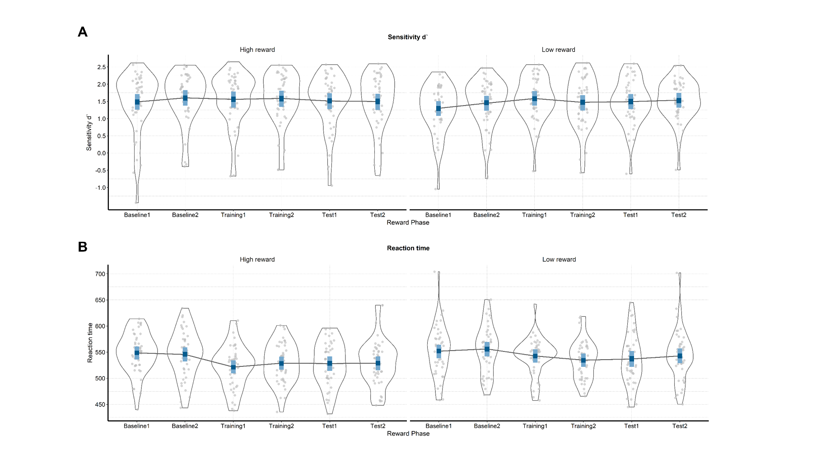

**Supplementary Figure 1. Raw and modelled behavioral data in each half of each phase of the experiment.** On both plots raw participant data is represented with grey dots and their distribution. The winning model is presented in blue (dark blue – 50% HDIs and light blue – 95% HDIs). **A)** Sensitivity (d`) across the phases of the experiment for the conditions in which the target color is linked to either high or low value. **B)** Reaction times (ms) in the six phases when the target is related to high or low value.

|  |  |  |  |
| --- | --- | --- | --- |
| Supplementary Table 4  *Means and 95% HDIs of sensitivity and reaction times across six phases of the experiment* | | | |
| Reward phase | Value | Sensitivity (d`) | Reaction times (milliseconds) |
| Baseline 1 | High | 1.49 [1.26, 1.71] | 548.63 [535.91, 560.72] |
| Baseline 1 | Low | 1.30 [1.08, 1.51] | 551.89 [538.38, 564.15] |
| Baseline 2 | High | 1.60 [1.38, 1.83] | 545.50 [532.36, 559.34] |
| Baseline 2 | Low | 1.45 [1.23, 1.66] | 556.12 [542.01, 569.51] |
| Training 1 | High | 1.56 [1.32, 1.79] | 521.46 [509.29, 534.18] |
| Training 1 | Low | 1.58 [1.38, 1.80] | 542.74 [529.90, 555.54] |
| Training 2 | High | 1.59 [1.34, 1.81] | 528.94 [516.56, 541.59] |
| Training 2 | Low | 1.47 [1.24, 1.68] | 534.70 [521.78, 547.53] |
| Test 1 | High | 1.51 [1.28, 1.74] | 528.27 [514.43, 542.01] |
| Test 1 | Low | 1.49 [1.28, 1.71] | 536.87 [522.00, 552.32] |
| Test 2 | High | 1.50 [1.25, 1.72] | 528.92 [515.37, 542.04] |
| Test 2 | Low | 1.54 [1.32, 1.75] | 542.76 [528.68, 557.15] |

## Software for data visualization and analysis

Visualization and statistical analyses were performed using R v3.4.4 (R Core Team, 2017) via RStudio v1.1.453 (RStudio Team, 2015). We used the following packages (and their respective dependencies):

• data manipulation: tidyverse v1.2.1 (Wickham, 2017);

• statistical analyses: Rmisc v1.5 (Hope, 2013), brms v2.3.1 (Bürkner, 2016); psych

• visualization: cowplot v0.9.2 (Wilke, 2016), yarrr v0.1.5 (Phillips, 2016), viridis v0.5.1 (Garnier, 2018), eegUtils v0.2.0 (Craddock, 2018), BEST (J. K. Kruschke & Meredith, 2017);

• report generation: pacman v0.4.6 (Rinker & Kurkiewicz, n.d.), knitr v1.20 (Xie, 2018); here.

# Acknowledgements

This work was supported by the Special Research Fund (BOF) of Ghent University [grant #01D02415 awarded to IG; grant # BOF14/PDO/123 awarded to AS] and the Concerted Research Action Grant of Ghent University [grant number BOF16/GOA/017 awarded to EHWK]. Add funding for Gilles and Søren. The funding sources had no involvement in the study design; collection, analysis, and interpretation of data; writing of the report; and decision to submit the article for publication.

We would like to thank Ladislas Nalborczyk for discussions about statistical analyses of the data and Dr. Inez Greven for help with data collection.

# Author contributions

Author contributions are coded according to the CRediT taxonomy (Allen, Scott, Brand, Hlava, & Altman, 2014). For details, see <https://www.casrai.org/credit.html>.

IG, AS, and SKA conceived the study. SKA and IG programmed the experimental paradigm. SKA, GP, and EHWK contributed reagents/materials/tools. IG collected the data, supervised by AS. IG and AS analyzed the data. IG and AS wrote the main manuscript text. IG, AS, GP, EHWK, and SKA reviewed and critically revised the manuscript.

# Data availability

Raw and pre-processed data, materials, and analysis scripts are available at: https://osf.io/kjds3/.

# References

Allen, L., Scott, J., Brand, A., Hlava, M., & Altman, M. (2014). Publishing: Credit where credit is due. *Nature*, *508*(7496), 312–313. https://doi.org/10.1038/508312a

Andersen, S. K., Müller, M. M., & Hillyard, S. A. (2012). Tracking the allocation of attention in visual scenes with steady-state evoked potentials. In *Cognitive neuroscience of attention* (pp. 197–216).

Andersen, S K, & Müller, M. M. (2010). Behavioral performance follows the time course of neural facilitation and suppression during cued shifts of feature-selective attention. *Proceedings of the National Academy of Sciences of the United States of America*, *107*(31), 13878–13882. https://doi.org/10.1073/pnas.1002436107

Andersen, Søren K., Hillyard, S. A., & Müller, M. M. (2008). Attention Facilitates Multiple Stimulus Features in Parallel in Human Visual Cortex. *Current Biology*, *18*(13), 1006–1009. https://doi.org/10.1016/j.cub.2008.06.030

Anderson, B. A. (2016). The attention habit: How reward learning shapes attentional selection. *Annals of the New York Academy of Sciences*, *1369*(1), 24–39. https://doi.org/10.1111/nyas.12957

Anderson, B. a, Laurent, P. a, & Yantis, S. (2011). Value-driven attentional capture. *Proceedings of the National Academy of Sciences*, *108*(25), 10367–10371. https://doi.org/10.1073/pnas.1104047108

Awh, E., Belopolsky, A. V., & Theeuwes, J. (2012). Top-down versus bottom-up attentional control: A failed theoretical dichotomy. *Trends in Cognitive Sciences*, *16*(8), 437–443. https://doi.org/10.1016/j.tics.2012.06.010

Botvinick, M. M., & Braver, T. S. (2015). Motivation and Cognitive Control : From Behavior to Neural Mechanism. *Annual Review of Psychology*, (September 2014), 1–31. https://doi.org/10.1146/annurev-psych-010814-015044

Brown, J. W., & Alexander, W. H. (2017). Foraging Value, Risk Avoidance, and Multiple Control Signals: How the Anterior Cingulate Cortex Controls Value-based Decision-making. *Journal of Cognitive Neuroscience*, *29*(10), 1656–1673. https://doi.org/10.1162/jocn_a_01140

Bürkner, P.-C. (2016). brms: An R package for Bayesian multilevel models using Stan. *Journal of Statistical Software*, *80*(1), 1–28.

Bürkner, P.-C. (2017). Advanced Bayesian Multilevel Modeling with the R Package brms. *ArXiv:1705.11123*.

Carpenter, B., Gelman, A., Hoffman, M., Lee, D., Goodrich, B., Betancourt, M., … Riddell, A. (2016). Stan: A probabilistic programming language. *Journal of Statistical Software*, *2*(20), 1–37.

Chatrian, G. E., Lettich, E., & Nelson, P. L. (1985). Ten percent electrode system for topographic studies of spontaneous and evoked EEG activities. *American Journal of EEG Technology*, *25*(2).

Chelazzi, L., Perlato, A., Santandrea, E., & Della Libera, C. (2013). Rewards teach visual selective attention. *Vision Research*, *85*, 58–62. https://doi.org/10.1016/j.visres.2012.12.005

Chun, M. M., Golomb, J. D., & Turk-Browne, N. B. (2011). A Taxonomy of External and Internal Attention. *Annual Review of Psychology*, *62*(1), 73–101. https://doi.org/10.1146/annurev.psych.093008.100427

Corbetta, M., & Shulman, G. L. (2002). Control of Goal-Directed and Stimulus-Driven Attention in the Brain. *Nature Reviews Neuroscience*, *3*(3), 215–229. https://doi.org/10.1038/nrn755

Craddock, M. (2018). craddm/eegUtils: eegUtils (Version v0.2.0). Zenodo.

Della Libera, C., & Chelazzi, L. (2009). Learning to attend and to ignore is a matter of gains and losses. *Psychological Science*, *20*(6), 778–784. https://doi.org/10.1111/j.1467-9280.2009.02360.x

Delorme, A., & Makeig, S. (2004). EEGLAB: an open sorce toolbox for analysis of single-trail EEG dynamics including independent component anlaysis. *Journal of Neuroscience Methods*, *134*, 9–21. https://doi.org/10.1016/j.jneumeth.2003.10.009

Desimone, R., & Duncan, J. (1995). Neural Mechanisms of Selective Visual. *Annual Review of Neuroscience*, *18*(1), 193–222. https://doi.org/10.1146/annurev.ne.18.030195.001205

Donohue, S. E., Hopf, J.-M., Bartsch, M. V., Schoenfeld, M. A., Heinze, H.-J., & Woldorff, M. G. (2016). The Rapid Capture of Attention by Rewarded Objects. *Journal of Cognitive Neuroscience*, *28*(4), 529–541. https://doi.org/10.1162/jocn_a_00917

Etzel, J. A., Cole, M. W., Zacks, J. M., Kay, K. N., & Braver, T. S. (2016). Reward Motivation Enhances Task Coding in Frontoparietal Cortex. *Cerebral Cortex*, *26*(4), 1647–1659. https://doi.org/10.1093/cercor/bhu327

Failing, M. F., & Theeuwes, J. (2014). Exogenous visual orienting by reward. *Journal of Vision*, *14*(2014), 1–9. https://doi.org/10.1167/14.5.6.doi

Failing, M., & Theeuwes, J. (2017). Selection history: How reward modulates selectivity of visual attention. *Psychonomic Bulletin and Review*, 1–25. https://doi.org/10.3758/s13423-017-1380-y

Franken, I. H. A., Muris, P., & Rassin, E. (2005). Psychometric properties of the Dutch BIS/BAS scales. *Journal of Psychopathology and Behavioral Assessment*, *27*(1), 25–30. https://doi.org/10.1007/s10862-005-3262-2

Garnier, S. (2018). viridis: Default Color Maps from ‘matplotlib.’ R package version 0.3.

Gelman, A., Goodrich, B., Gabry, J., & Ali, I. (2017). R-squared for Bayesian regression models. *Unpublished via Http://Www. Stat. Columbia. Edu/~ Gelman/Research/Unpublished.* Retrieved from http://www.stat.columbia.edu/~gelman/research/unpublished/bayes_R2.pdf

Gelman, A., & Rubin, D. B. (1992). Inference from Iterative Simulation Using Multiple Sequences. *Statistical Science*, *7*(4), 457–472. https://doi.org/10.1214/ss/1177011136

Hautus, M. J. (1995). Corrections for extreme proportions and their biasing effects on estimated values of d′. *Behavior Research Methods, Instruments, & Computers*, *27*(1), 46–51. https://doi.org/10.3758/BF03203619

Hickey, C., Chelazzi, L., & Theeuwes, J. (2010). Reward Changes Salience in Human Vision via the Anterior Cingulate. *Journal of Neuroscience*, *30*(33), 11096–11103. https://doi.org/10.1523/JNEUROSCI.1026-10.2010

Hickey, C., & Peelen, M. V. (2015a). Neural mechanisms of incentive salience in naturalistic human vision. *Neuron*, *85*(3), 512–518. https://doi.org/10.1016/j.neuron.2014.12.049

Hickey, C., & Peelen, M. V. (2015b). Neural Mechanisms of Incentive Salience in Naturalistic Human Vision Report Neural Mechanisms of Incentive Salience in Naturalistic Human Vision. *Neuron*, *85*(3), 512–518. https://doi.org/10.1016/j.neuron.2014.12.049

Holroyd, C. B., & McClure, S. M. (2015). Hierarchical control over effortful behavior by rodent medial frontal cortex: A computational model. *Psychological Review*, *122*(1), 54–83. https://doi.org/10.1037/a0038339

Hope, R. M. (2013). Rmisc: Ryan miscellaneous. R package version, 1(5).

Junghöfer, M., Elbert, T., Tucker, D. O. N. M., & Rockstroh, B. (2000). Statistical control of artifacts in dense array EEG 0 MEG studies. *Wiley Online Library*, 523–532. Retrieved from http://onlinelibrary.wiley.com/doi/10.1111/1469-8986.3740523/full

Krebs, R. M., Boehler, C. N., Roberts, K. C., Song, A. W., & Woldorff, M. G. (2012). The involvement of the dopaminergic midbrain and cortico-striatal-thalamic circuits in the integration of reward prospect and attentional task demands. *Cerebral Cortex*, *22*(3), 607–615. https://doi.org/10.1093/cercor/bhr134

Krebs, R. M., & Woldorff, M. G. (2017). Cognitive control and reward. *The Wiley Handbook of Cognitive Control*, 422–439. https://doi.org/10.1002/9781118920497.ch24

Kruschke, J. K., & Meredith, M. (2017). BEST: Bayesian Estimation Supersedes the t-Test.

Kruschke, John K. (2014). *Doing Bayesian data analysis: A tutorial with R, JAGS, and Stan, second edition*. *Doing Bayesian Data Analysis: A Tutorial with R, JAGS, and Stan, Second Edition* (2nd ed.). Elsevier Inc. https://doi.org/10.1016/B978-0-12-405888-0.09999-2

Luque, D., Beesley, T., Morris, R. W., Jack, B. N., Griffiths, O., Whitford, T. J., & Le Pelley, M. E. (2017). Goal-Directed and Habit-Like Modulations of Stimulus Processing during Reinforcement Learning. *The Journal of Neuroscience*, *37*(11), 3009–3017. https://doi.org/10.1523/jneurosci.3205-16.2017

MacLean, M. H., & Giesbrecht, B. (2015). Neural evidence reveals the rapid effects of reward history on selective attention. *Brain Research*, *1606*, 86–94. https://doi.org/10.1016/j.brainres.2015.02.016

Macmillan, N. A., & Creelman, C. D. (2004). *Detection theory: A user’s guide*. Psychology press.

McElreath, R. (2016). *Statistical Rethinking: A Bayesian Course with Examples in R and Stan*. Chapman Hall - CRC.

Muller, M. M., Andersen, S., Trujillo, N. J., Valdes-Sosa, P., Malinowski, P., & Hillyard, S. A. (2006). Feature-selective attention enhances color signals in early visual areas of the human brain. *Proceedings of the National Academy of Sciences*, *103*(38), 14250–14254. https://doi.org/10.1073/pnas.0606668103

Musslick, S., Shenhav, A., Botvinick, M. M., & Cohen, J. D. (2015). A computational model of control allocation based on the Expected Value of Control. *Reinforcement Learning and Decision Making Conference*, *59*(1978), 2014.

Nalborczyk, L., & Bürkner, P.-C. (2019). An Introduction to Bayesian Multilevel Models Using brms: A Case Study of Gender Effects on Vowel Variability in Standard Indonesian. *Journal of Speech, Language, and Hearing Research*.

Nolan, H., Whelan, R., & Reilly, R. B. (2010). FASTER: Fully Automated Statistical Thresholding for EEG artifact Rejection. *Journal of Neuroscience Methods*, *192*(1), 152–162. https://doi.org/10.1016/j.jneumeth.2010.07.015

Norcia, A. M., Appelbaum, L. G., Ales, J. M., Cottereau, B. R., & Rossion, B. (2015). The steady-state visual evoked potential in vision research : A review. *Journal of Vision*, *15*(6), 1–46. https://doi.org/10.1167/15.6.4.doi

Padmala, S., & Pessoa, L. (2011). Reward reduces conflict by enhancing attentional control and biasing visual cortical processing. *Journal of Cognitive Neuroscience*, *23*(11), 3419–3432. https://doi.org/10.1162/jocn_a_00011

Pallier, C. (2002). Computing discriminability and bias with the R software. Retrieved July 25, 2019, from http://www.pallier.org/pdfs/aprime.pdf

Perrin, F., Pernier, J., Bertrand, O., & Echallier, J. F. (1989). Spherical splines for scalp potential and current density mapping. *Electroencephalography and Clinical Neurophysiology*, *72*(2), 184–187. https://doi.org/10.1016/0013-4694(89)90180-6

Pessoa, L. (2015). Multiple influences of reward on perception and attention. *Visual Cognition*, *23*(1–2), 272–290. https://doi.org/10.1080/13506285.2014.974729

Pessoa, L., & Engelmann, J. B. (2010). Embedding reward signals into perception and cognition. *Frontiers in Neuroscience*, *4*(September), 1–8. https://doi.org/10.3389/fnins.2010.00017

Phillips, N. (2016). Yarrr: A companion to the e-book YaRrr!: The Pirate’s Guide to R. R package version 0.1.

Posner, M. I. (1980). Orienting of attention. *The Quarterly Journal of Experimental Psychology*, *32*(1), 3–25. https://doi.org/10.1080/00335558008248231

Qi, S., Zeng, Q., Ding, C., & Li, H. (2013). Neural correlates of reward-driven attentional capture in visual search. *Brain Research*, *1532*, 32–43. https://doi.org/10.1016/j.brainres.2013.07.044

R Core Team. (2017). R: A Language and Environment for Statistical Computing. R Foundation for Statistical Computing.

Rinker, T., & Kurkiewicz, D. (n.d.). pacman: Package Management for R.

Roelfsema, P. R., van Ooyen, A., & Watanabe, T. (2010). Perceptual learning rules based on reinforcers and attention. *Trends in Cognitive Sciences*, *14*(2), 64–71. https://doi.org/10.1016/j.tics.2009.11.005

RStudio Team. (2015). Integrated Development for R. RStudio, Inc.

Schevernels, H., Krebs, R. M., Santens, P., Woldorff, M. G., & Boehler, C. N. (2014). Task preparation processes related to reward prediction precede those related to task-difficulty expectation. *NeuroImage*, *84*, 639–647. https://doi.org/10.1016/j.neuroimage.2013.09.039

Serences, J. T. (2008). Value-Based Modulations in Human Visual Cortex. *Neuron*, *60*(6), 1169–1181. https://doi.org/10.1016/j.neuron.2008.10.051

Shenhav, A., Botvinick, M., & Cohen, J. (2013). The expected value of control: An integrative theory of anterior cingulate cortex function. *Neuron*, *79*(2), 217–240. https://doi.org/10.1016/j.neuron.2013.07.007

Tankelevitch, L., Spaak, E., Rushworth, M. F. S., & Stokes, M. G. (2019). Previously reward-associated stimuli capture spatial attention in the absence of changes in the corresponding sensory representations as measured with {MEG}. *BioRxiv*, 622589. https://doi.org/10.1101/622589

Theeuwes, J. (2010). Top-down and bottom-up control of visual selection. *Acta Psychologica*, *135*(2), 77–99. https://doi.org/10.1016/j.actpsy.2010.02.006

Van der Does, A. J. W. (2002). *Handleiding bij de Nederlandse versie van beck depression inventory—second edition (BDI-II-NL). [The Dutch version of the Beck depression inventory].* Amsterdam: Harcourt.

Verguts, T., Vassena, E., & Silvetti, M. (2015). Adaptive effort investment in cognitive and physical tasks: a neurocomputational model. *Frontiers in Behavioral Neuroscience*, *9*(March). https://doi.org/10.3389/fnbeh.2015.00057

Watanabe, S. (2010). Asymptotic Equivalence of Bayes Cross Validation and Widely Applicable Information Criterion in Singular Learning Theory, *11*, 3571–3594. Retrieved from http://arxiv.org/abs/1004.2316

Wickham, H. (2017). Tidyverse: Easily install and load ’tidyverse’ packages. R package version, 1(1).

Wilke, C. O. (2016). cowplot: streamlined plot theme and plot annotations for ‘ggplot2.’ CRAN Repos.

Wisniewski, D., Reverberi, C., Momennejad, I., Kahnt, T., & Haynes, J.-D. (2015). The Role of the Parietal Cortex in the Representation of Task-Reward Associations. *Journal of Neuroscience*, *35*(36), 12355–12365. https://doi.org/10.1523/jneurosci.4882-14.2015

Xie, Y. (2018). knitr: A General-Purpose Package for Dynamic Report Generation in R.

1. In brief, estimates that strongly deviate from the mean (e.g., a participant performing the task much worse than the average of the total sample) will be pulled toward the group mean (McElreath, 2016). This advantageous property prevents extreme values from having large effects on the results.